Why Lasso Regression creates sparsity?

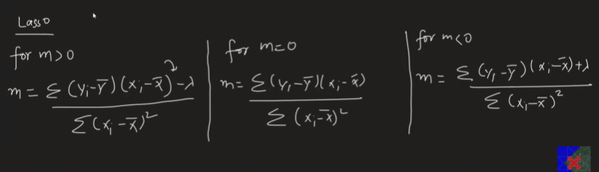

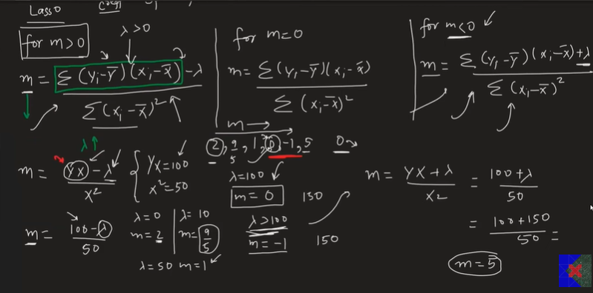
These are clean, exam-ready English notes based on the lecture.

Why Does Lasso Regression (L1) Create Sparsity?

Interview Question
Q: Why does Lasso Regression (L1 Regularization) make some coefficients exactly 0, while Ridge Regression (L2 Regularization) never does?
This is one of the most frequently asked Machine Learning interview questions.

What is Sparsity?
Sparsity means that many model coefficients become exactly zero.
Example:
Feature | Coefficient
Age | 2.4
Salary | 0
Experience | 5.1
Gender | 0
City | 0
Features with coefficient 0 are automatically removed from the model.
This is why Lasso performs Feature Selection.

Ridge Regression vs Lasso Regression

Ridge Regression (L2)
Penalty:
[
\lambda \sum w_i^2
]
Characteristics:
- Shrinks coefficients
- Never makes them exactly zero
- All features remain in the model
Example:
5.2
3.8
1.4
0.2
0.05
0.001
Values become very small but never reach 0.

Lasso Regression (L1)
Penalty:
[
\lambda \sum |w_i|
]
Characteristics:
- Shrinks coefficients
- Can make coefficients exactly zero
- Performs automatic feature selection
Example:
5.2
3.4
1.1
0
0
0

Why Does Lasso Create Sparsity?
To understand this, consider a simple linear regression with one feature.
Prediction equation:
[
y = mx + b
]
Here,
- m = slope (coefficient)
- b = intercept

Normal Linear Regression
The coefficient is computed as
[
m=
\frac{\sum (x-\bar{x})(y-\bar{y})}
{\sum (x-\bar{x})^2}
]
Notice that λ is not present.

Ridge Regression Formula
After adding L2 regularization,
[
m=
\frac{\sum (x-\bar{x})(y-\bar{y})}
{\sum (x-\bar{x})^2+\lambda}
]
Observe carefully.
The regularization term λ is added in the denominator.

What happens if λ increases?
Suppose
Numerator = 100
Denominator = 20
Initially
[
m=\frac{100}{20}=5
]
Increase λ
[
m=\frac{100}{20+80}=1
]
Increase λ even more
[
m=\frac{100}{20+1000}=0.098
]
Increase λ to a huge value
0.009
0.0008
0.00003
The coefficient keeps decreasing.
But it never becomes exactly zero because the numerator is still non-zero.

Lasso Regression Formula
For Lasso, after differentiation,
when
[
m>0
]
the coefficient becomes
[
m=
\frac{\sum(x-\bar{x})(y-\bar{y})-\lambda}
{\sum(x-\bar{x})^2}
]
Notice something important.
Now λ is in the numerator, not the denominator.

Why Does It Reach Zero?
Suppose
Numerator = 100
Denominator = 50
Then
[
m=\frac{100-\lambda}{50}
]

λ = 0
[
m=\frac{100}{50}=2
]

λ = 50
[
m=\frac{50}{50}=1
]

λ = 100
[
m=\frac{0}{50}=0
]
The coefficient becomes exactly 0.

What if λ Becomes Larger?
Suppose
[
\lambda=150
]
Mathematically,
[
m=\frac{100-150}{50}
=-1
]
But this equation was derived assuming
[
m>0
]
So it is no longer valid.
The optimization switches to another case.
Instead of allowing the coefficient to become negative, the optimization stops at zero.
Therefore
2
↓

1
↓

0

(stops here)
It never crosses zero.

Negative Coefficient Case
If
[
m<0
]
the solution becomes
[
m=
\frac{\sum(x-\bar{x})(y-\bar{y})+\lambda}
{\sum(x-\bar{x})^2}
]
Again,
as λ increases,
the coefficient moves toward zero.
Once it reaches zero,
the optimization again stops there.

Why Does Ridge Never Stop at Zero?
Ridge formula
[
m=
\frac{\text{Numerator}}
{\text{Denominator}+\lambda}
]
Even if λ becomes extremely large,
the numerator never becomes zero.
Therefore
5
↓

2

↓

0.5

↓

0.05

↓

0.0001
It only approaches zero.
It never equals zero.

Key Difference
Ridge Regression | Lasso Regression
Uses L2 penalty | Uses L1 penalty
λ added in denominator | λ subtracts from numerator (piecewise solution)
Coefficients shrink | Coefficients shrink
Never becomes exactly 0 | Can become exactly 0
No feature selection | Automatic feature selection
Dense model | Sparse model

Why Lasso Performs Feature Selection
As λ increases,
less important feature coefficients become
0
Once a coefficient becomes zero,
that feature contributes nothing to prediction.
Therefore it can be removed.
This is called
Automatic Feature Selection.

Interview Answer (30 Seconds)
Lasso Regression creates sparsity because the L1 penalty leads to a soft-thresholding solution. As the regularization parameter λ increases, coefficients are reduced toward zero, and once the penalty exceeds a coefficient's contribution, that coefficient becomes exactly zero. Ridge Regression uses an L2 penalty, which only shrinks coefficients toward zero but never makes them exactly zero because the penalty acts through the denominator rather than producing a thresholding effect. Therefore, Lasso performs automatic feature selection, while Ridge does not.

Important Exam Points
- Lasso uses L1 Regularization.
- Ridge uses L2 Regularization.
- Lasso creates sparse models.
- Sparse means many coefficients become exactly zero.
- Lasso performs automatic feature selection.
- Ridge keeps all features.
- Ridge shrinks coefficients but never makes them exactly zero.
- This is one of the most common Machine Learning interview questions.

